A PROJECT REPORT

Presented to Intelint Technologies

Bangalore, Karnataka.

TEAM MEMBERS

* Kumaran.R
* Susmitha.k.s
* Vignesh.E
* Tamilselvan.R

**Description**.

DRUG LOFT is an online pharmacy registered as a limited liability company with its head office in Newyork, Manhattan. The sole purpose of DRUG LOFT is to provide prescription medicines at a reasonable price to its customers and we plan to achieve this by working efficiently and cutting down the operating cost. The company’s top three goals are to provide prescription medicines to the customers at a lower price in the market, make prescription medicines easily available to the customers and be known as America’s most reliable and trusted pharmacy. DRUG LOFT ’s unique selling proposition is an overnight delivery system which promises to deliver drugs to the customer’s doorstep. Additionally, there will be a discount for the customers within a 5-km radius of the warehouse.

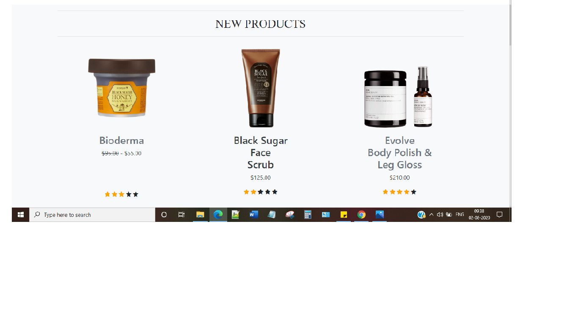

**Features**

**E-prescription:**

The electronic prescription feature can be used by the pharmacy to manage refills and allows doctors to send the new refills directly into the pharmacy management system, allowing rapid dispensing of the medicines. Apart from this, there will be no confusion in offering the right prescription between the physician and the patient.

**SMS and Notification:**

With the use of a pharmacy management system, the pharmacist can schedule text messages to be sent to patients intimating them before their prescriptions running out.

The patients can then let the pharmacist if they need a refill, simply by responding to the message. The status updates let the pharmacist keep in touch with the patients, ensuring patient satisfaction.

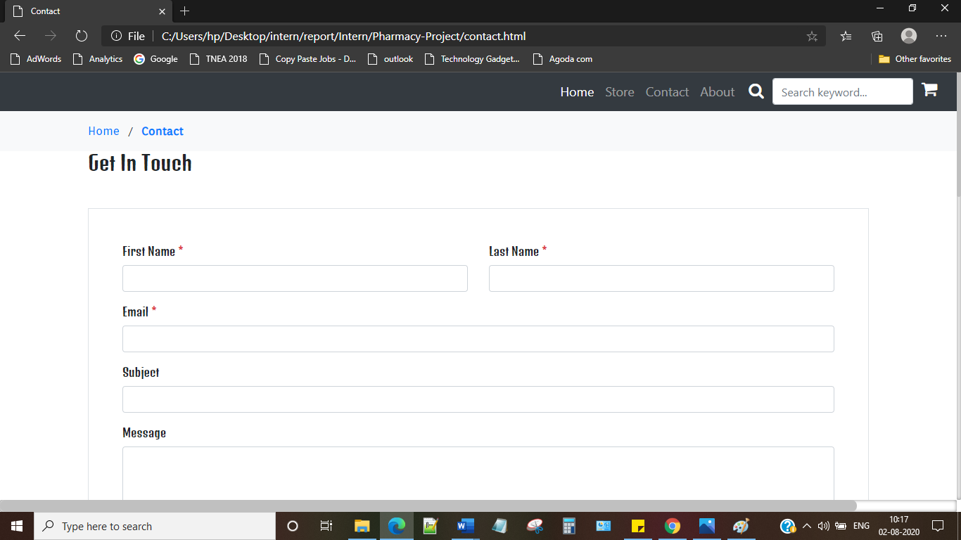

**Multi-Store and Multi-Location Support:**

The user can manage stores at multiple locations easily with a pharmacy information system.

Data about stock levels, sales, returns from multiple stores can be viewed in a single software. Overall reports for the entire chain of stores can be generated, giving the user a complete overview of profit, loss, stock levels, etc.

**User Management Module:**

This feature allows restricted access to various users. Access to various features can be limited for different users, for easy management. This authentication is classified into two conditions namely

**Administrator User:**

The user can control the buying and selling process, list the medicines, view the stock and perform other tasks. The user will be able to view the pharmacy list and the pharmacy map easily. It plays an essential role in controlling the sales and stocks being processed every day.

**Administrator Authentication User:**

The users who are authenticated can view all process including selling reports, transactions, manipulate the medicine list and the medicine stock. This feature also helps to track regular activities and generate daily accounts by utilizing the multisite software.

User stories

|  |  |  |  |
| --- | --- | --- | --- |
| **User Story**  **Number:** | **As a** | **I want to** | **So that** |
| **1.** | Project Head | Know All the  Requirements which Fulfill the User | They can easily interact  With our Environment |
| **2.** | Team Member | know the  Lifecycle of the  Project | I can easily understand about the project and collaborate with the team |
| **3.** | Customer | know what the website is for and  And what can I order in that | I can easily buys what I want and easily Track my order |
| **4.** | Web Developer | Know how to design the page user friendly and comfortably | They can comfortably Interact with the Website |

Tools & Technologies

* HTML
* CSS
* Programming language:Javascript
* Framework:Bootstrap
* IDE : Sublime text

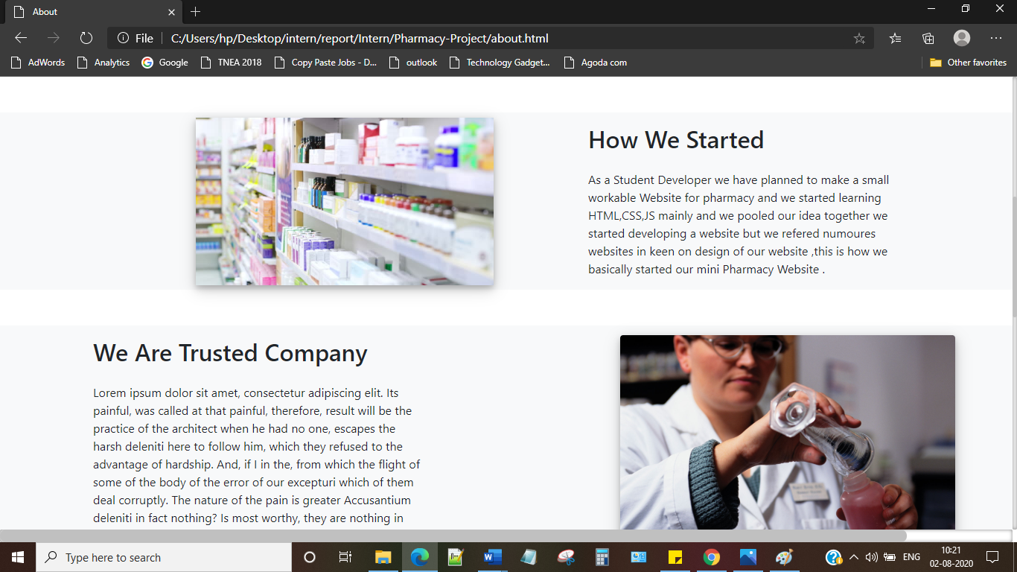

PROJECT URL

